|  |  |  |  |  |  |
| --- | --- | --- | --- | --- | --- |
| Name: | ___________________________________________________ | | | | Date: *___________* |
| pact jpg1 | **Year 11 Mathematics: Applications**  **Investigation 2, 2015**  **Topic – Matrices**  **Take home component** | | | |  |
| **Important Information:**  *Although the take-home component is not worth any marks, it is essential in preparation for the in-class component. Knowledge and skills gained will be extended in the in-class validation component. This in-class validation will be completed under test conditions on the day in which this take-home component is due. The take-home component may be used when completing the in-class component. Contact may be made to parent(s) if the take-home component is not available for submission (at the start of the lesson).* | | | | | |
| **Date out:** | | *Week ____ Date _____________* | **Date Due:** | *Week ____ Date _____________* | |
| **Take home component weighting:** | | *0% of the year* | **In-class component weighting:** | *10% of the semester* | |
| **AIM:** *In this assessment, you will be investigating how matrices are used in to assist in data analysis.* | | | | | |

**Scenario 1**] Estelle wants to purchase a new iPad mini. She is not sure which will be the best option for her, so she decides to organize all of the data she has compiled into a table, in order to easily compare her options.

|  |  |  |  |  |  |
| --- | --- | --- | --- | --- | --- |
| **Choice** | **Price** | **Memory** | **Pixels** | **Weight** | **Depth** |
| iPad Mini 1 | 299 | 16GB | 163 | 308g | 7.2mm |
| iPad Mini 2 | 369 | 16GB | 326 | 331g | 7.5mm |
| iPad Mini 2 | 429 | 32GB | 326 | 331g | 7.5mm |
| iPad Mini 3 | 499 | 16GB | 326 | 331g | 7.5mm |
| iPad Mini 3 | 619 | 64GB | 326 | 331g | 7.5mm |
| iPad Mini 3 | 739 | 128GB | 326 | 331g | 7.5mm |

The table above was compiled from information she found on Wi-Fi iPads from the Apple Store. Estelle wants to remember this information quickly so she can take it into stores and compare their prices. She decides to convert her table into a matrix to make it easier to remember.

*A* ***matrix*** *is a rectangular array of numbers or variables in vertical columns and horizontal rows. A matrix is usually enclosed in a set of large brackets. Each of the numerical values in a matrix have a purpose and are referred to as* ***elements****. A matrix that has m rows and n columns is referred to as a* ***m x n matrix****. If the matrix has the same number of rows and columns it is called a* ***square matrix****.*

***Example:***

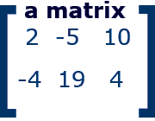 *where the elements are sorted as* 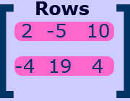 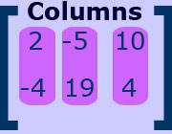

**1.** Use the information in the table Estelle had created, to construct a 6 x 6 matrix.

*[Hint: Only use the numerical values in the matrix]*

Estelle went online to JB HI-FI website, to compare the prices and she found the following information;



Apple iPad mini 3 Wi-Fi 16GB $498

Apple iPad mini 1 16GB Wi-Fi $298

Apple iPad mini 2 32GB Wi-Fi $588

Apple iPad mini 2 16GB Wi-Fi $527

Apple iPad mini 3 Wi-Fi 128GB $847

Apple iPad mini 3 Wi-Fi 64GB $618

**2.** Construct a 6 x 6 matrix similar to the one in task 1 then insert the numerical information obtained from the JB HI-FI website.

**Scenario 2]** The following game results were tabulated for round 1 of the AFL 2015;

HAWTHORN VS GEELONG CATS

|  |  |  |  |  |
| --- | --- | --- | --- | --- |
|  | 1ST | 2ND | 3RD | 4TH |
| HAWTHORN | 3 3 | 9 7 | 16 13 | 17 21 |
| GEELONG CATS | 4 3 | 5 3 | 6 6 | 8 13 |
|  |  |  |  |  |

The columns 1st, 2nd, 3rd and 4th stand for the quarters of the game. The two numbers in each cell are the number of goals followed by the number of behinds scored each quarter.

***Multiplying Matrices:*** *You can multiply Matrix A and B if and only if the number of Columns in A is equal to the number of rows in B. The resulting matrix will be formed by multiplying each term in each row of the first matrix by each term in each column of the second matrix and adding each of these resultant terms together to form a new matrix.*

*Example:*

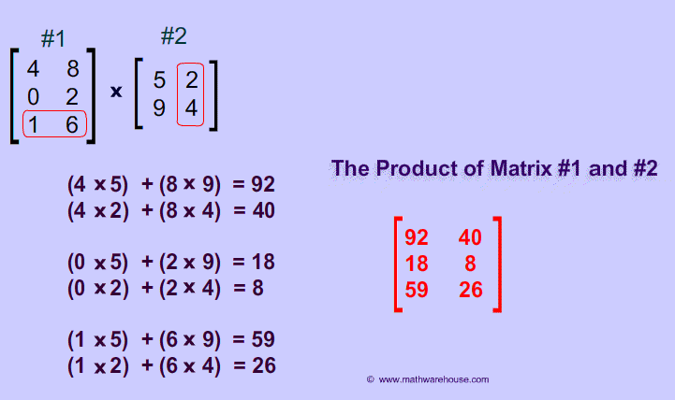

**1.**  Construct a 4 x 2 matrix for Hawthorn’s results and a 4 x 2 matrix for Geelong’s results and call them matrix H and matrix G.

Matrix H Matrix G

**2.** Given that each goal is worth 6 points and each behind is worth 1 point, multiply Matrix H and Matrix G by matrix S (Scores) to determine which team won the match. This will be the team with the largest number in the bottom position of the resultant matrix either [H x S] or [G x S].

Matrix H Matrix S Matrix H x S

X 6 =

1

Matrix G Matrix S Matrix G x S

X 6 =

1

Winning Side was ______________________________________ .

3. Use the same method as above to determine the winners of the remaining games of the AFL round 1 for 2015.

|  |  |  |  |  |
| --- | --- | --- | --- | --- |
|  | 1ST | 2ND | 3RD | 4TH |
| FREMANTLE | 2 1 | 5 3 | 7 5 | 11 9 |
| PORT ADELAIDE | 2 5 | 5 5 | 7 8 | 10 8 |

|  |  |  |  |  |
| --- | --- | --- | --- | --- |
|  | 1ST | 2ND | 3RD | 4TH |
| ADELAIDE CROWS | 6 4 | 12 10 | 15 12 | 21 14 |
| NORTH MELBOURNE | 2 1 | 3 1 | 9 4 | 9 9 |

|  |  |  |  |  |
| --- | --- | --- | --- | --- |
|  | 1ST | 2ND | 3RD | 4TH |
| ST KILDA | 3 0 | 5 2 | 7 5 | 11 12 |
| GWS GIANTS | 3 5 | 7 9 | 9 12 | 12 15 |

|  |  |  |  |  |
| --- | --- | --- | --- | --- |
|  | 1ST | 2ND | 3RD | 4TH |
| BRISBANE LIONS | 2 3 | 3 5 | 7 6 | 11 8 |
| COLLINGWOOD | 3 3 | 7 6 | 12 11 | 12 14 |

|  |  |  |  |  |  |
| --- | --- | --- | --- | --- | --- |
|  | 1ST | 2ND | 3RD | |  |
| WESTERN BULLDOGS | 4 0 | 7 5 | 11 6 | 14 13 |
| WEST COAST EAGLES | 3 1 | 7 1 | 12 2 | 14 3 |

|  |  |  |  |  |
| --- | --- | --- | --- | --- |
|  | 1ST | 2ND | 3RD | 4TH |
| SYDNEY SWANS | 0 1 | 1 7 | 3 8 | 10 12 |
| ESSENDON | 4 3 | 5 5 | 9 6 | 9 6 |

|  |  |  |  |  |
| --- | --- | --- | --- | --- |
|  | 1ST | 2ND | 3RD | 4TH |
| MELBOURNE | 2 5 | 7 7 | 12 9 | 17 13 |
| GOLD COAST SUNS | 1 2 | 3 6 | 8 8 | 13 11 |

|  |  |  |  |  |
| --- | --- | --- | --- | --- |
|  | 1ST | 2ND | 3RD | 4TH |
| CARLTON | 4 7 | 6 9 | 6 12 | 11 12 |
| RICHMOND | 2 3 | 7 10 | 9 13 | 15 15 |

**~** End of Investigation**~**